**Move Canada**

Software Test Engineer

Homework Assignment

February 2012

Automated Testing Test: Magic Square.

==============================

Problem

-----------

Build a program (A) that tests another program (B) designed to accept

a N by M grid of numbers and determines if all the rows and all the

columns sum up to the same value.

Examples

------------

example runs of program B:

1.

input:

1 1

1 1

output:

yes

2.

input:

1 2

2 1

output:

yes

3.

input:

1 2

2 3

output:

no

example runs of program A:

where B is correctly working:

c:\>A.exe B.exe

ok

where B is incorrectly working:

C:\>A.exe B.exe

not ok:

1 1

1 1

returned: no

expected: yes

Submission

--------------

Post you code (and any instructions needed to make it function) to your personal http://github.com account in its own repository and submit a link to the repository.

**Marina Tishkova, solution for homework**

Note: Since the program B.exe task was to check if the square is magic, I changed the requirements:

instead of “a N by M grid of numbers” my square is A SQUARE, so N=M, and user enters just one dimension.

It is not difficult to follow your requirements and make it N and M different, but the name of the test was “Automated Testing Test: Magic Square”.

Two programs were written to use in the same directory. Program B.exe will write the file result.txt into this directory.

I could use the clipboard to pass the “yes” or “no” from the program B.exe or use the standard output in command line to be read by program A.exe, but to pass “yes” or “no” through the file was the easy solution.

My programs listings:

|  |
| --- |
| A.exe (A.au3) |
| #region ---Au3Recorder generated code Start (v3.3.7.0) ---  #region --- Internal functions Au3Recorder Start ---  Func _Au3RecordSetup()  Opt('WinWaitDelay',100)  Opt('WinDetectHiddenText',1)  Opt('MouseCoordMode',0)  EndFunc  Func _WinWaitActivate($title,$text,$timeout=0)  WinWait($title,$text,$timeout)  If Not WinActive($title,$text) Then WinActivate($title,$text)  WinWaitActive($title,$text,$timeout)  EndFunc  _AU3RecordSetup()  #endregion --- Internal functions Au3Recorder End ---  ; check if the AUT is B.exe  If $CMDLINE[1] <> "B.exe" Then  MsgBox(0, "Error", "Program A.exe will run on your AUT. Be Aware.")  EndIf  ; take a first parameter from command line as AUT  $sAUT = @WorkingDir & "\" & $CMDLINE[1]  MsgBox(0, "", "AUT is " & " " & $sAUT )  Sleep(2000)  ; run AUT  Local $foo = Run($sAUT)  ; wait until AUT is active  _WinWaitActivate($sAUT,"")  ; user input start  ; square dimension  $iSize = 2  Send($iSize)  Send("{ENTER}")  Global $vArray[$iSize][$iSize]  $vArray[0][0] = 1  $vArray[0][1] = 2  $vArray[1][0] = 2  $vArray[1][1] = 1  $sExpected = "yes"  ;$sExpected = "no"  ;creating an array list for bad result to show  $sNote = ""  For $iRow = 0 to ($iSize-1)  For $iColumn = 0 to ($iSize-1)  $sNote = $sNote & $vArray[$iRow][$iColumn] & " "  Next  $sNote = $sNote & @CRLF  Next  ; just make a program show user input slower  Sleep(1000)  ;Send("2{ENTER}1{ENTER}2{ENTER}2{ENTER}1{ENTER}")  For $iRow = 0 to ($iSize-1)  For $iColumn = 0 to ($iSize-1)  Send($vArray[$iRow][$iColumn])  Send("{ENTER}")  Next  Sleep(1000)  Next  ; user input end  ; open file written by the AUT  $sFile = @WorkingDir & "\" & "result.txt"  Local $file = FileOpen($sFile, 0)  ; Check if file opened for reading OK  If $file = -1 Then  MsgBox(0, "Error", "Unable to open file.")  Exit  EndIf  ; Read in 3 characters at a time until the EOF is reached  While 1  Local $sResult = FileRead($file, 3)  If @error = -1 Then ExitLoop  ; check if actual result is equal to expected  If $sResult = $sExpected Then  $sTestResult = "ok"  Else  $sTestResult = "not ok:" & @CRLF& $sNote & @CRLF & "returned: " & $sResult & @CRLF & "expected: " & $sExpected  EndIf  ; show test result  MsgBox(0, "Test result", $sTestResult)  WEnd  FileClose($file)  #endregion --- Au3Recorder generated code End --- |
| C:\Users\Marina\Desktop\AutoIT\MagicSquareTest\9.jpg  C:\Users\Marina\Desktop\AutoIT\MagicSquareTest\10.jpg |
| B-good.exe (MainProgram.cs in project B) |
| using System;  using System.Collections.Generic;  using System.Linq;  using System.Text;  namespace B  {  class MainProgram  {  static void Main(string[] args)  {  Console.Write("Enter square size: ");  int size = Convert.ToInt16(Console.ReadLine());  // array input  int[,] arr = new int[size,size];  for (int i = 0; i < size; i++)  {  for (int j = 0; j < size; j++)  {  Console.Write("a[{0},{1}]=", i, j);  arr[i, j] = Convert.ToInt16(Console.ReadLine());  }  }  // array output  Console.WriteLine("input:");  for (int i = 0; i < size; i++)  {  for (int j = 0; j < size; j++)  {  Console.Write("{0}", arr[i,j]);  }  Console.WriteLine();  }  // result "yes" or "no"  string result = "";  if ( IsMagic(size, arr) == true)  {  result = "yes";  //result = "no";  }  else  {  result = "no";  //result = "yes";  }  Console.WriteLine("output:");  Console.WriteLine(result);  //write "yes" or "no" to file result.txt  System.IO.File.WriteAllText(@"result.txt", result);  //make a console window stay for 5 sec  System.Threading.Thread.Sleep(5000);  } //Main    //if a suare is magic  static bool IsMagic(int size, int[,] array)  {  //count the first row sum  int sum = 0;  for (int j = 0; j < size; j++)  {  sum = sum + array[0, j] ;  }  //check if the sun is same in each row  for (int i = 0; i < size; i++)  {  int tmpSum = 0;  for (int j = 0; j < size; j++)  {  tmpSum = tmpSum + array[i, j];  }  if (tmpSum != sum)  return false;  }  //check if the sun is same in each column  for (int i = 0; i < size; i++)  {  int tmpSum = 0;  for (int j = 0; j < size; j++)  {  tmpSum = tmpSum + array[j, i];  }  if (tmpSum != sum)  return false;  }    // it seems sums are same  return true;  }//IsMagic  }  } |
| B-bad.exe (MainProgram.cs in project B) |
| using System;  using System.Collections.Generic;  using System.Linq;  using System.Text;  namespace B  {  class MainProgram  {  static void Main(string[] args)  {  Console.Write("Enter square size: ");  int size = Convert.ToInt16(Console.ReadLine());  // array input  int[,] arr = new int[size,size];  for (int i = 0; i < size; i++)  {  for (int j = 0; j < size; j++)  {  Console.Write("a[{0},{1}]=", i, j);  arr[i, j] = Convert.ToInt16(Console.ReadLine());  }  }  // array output  Console.WriteLine("input:");  for (int i = 0; i < size; i++)  {  for (int j = 0; j < size; j++)  {  Console.Write("{0}", arr[i,j]);  }  Console.WriteLine();  }  // result "yes" or "no"  string result = "";  if ( IsMagic(size, arr) == true)  {  //result = "yes";  result = "no";  }  else  {  //result = "no";  result = "yes";  }  Console.WriteLine("output:");  Console.WriteLine(result);  //write "yes" or "no" to file result.txt  System.IO.File.WriteAllText(@"result.txt", result);  //make a console window stay for 5 sec  System.Threading.Thread.Sleep(5000);  } //Main    //if a suare is magic  static bool IsMagic(int size, int[,] array)  {  //count the first row sum  int sum = 0;  for (int j = 0; j < size; j++)  {  sum = sum + array[0, j] ;  }  //check if the sun is same in each row  for (int i = 0; i < size; i++)  {  int tmpSum = 0;  for (int j = 0; j < size; j++)  {  tmpSum = tmpSum + array[i, j];  }  if (tmpSum != sum)  return false;  }  //check if the sun is same in each column  for (int i = 0; i < size; i++)  {  int tmpSum = 0;  for (int j = 0; j < size; j++)  {  tmpSum = tmpSum + array[j, i];  }  if (tmpSum != sum)  return false;  }    // it seems sums are same  return true;  }//IsMagic  }  } |

**How to run programs.**

Make a folder.

I made F:\MagicSquareTest. The name does not matter.

Copy files to this folder:

* A.exe
* B-bad.exe
* B-good.exe

Note: A file “result.txt” will be made by the B.exe program.

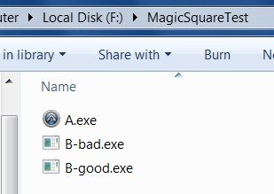

Open cmd.

Make this directory working directory.

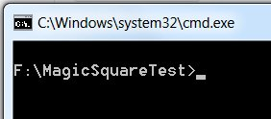

Run the program A.exe with the parameter B-good.exe (expected result is equal actual result).

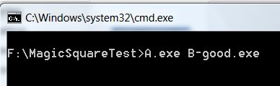

Since the program A.exe expected the program with the name B.exe to be the application under the test (AUT), the error message appears to warn you. See, if you have any text editor open, the result of running these programs could go into your file, you would not like that.

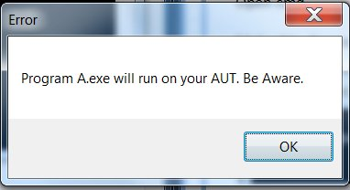

Click “Ok” button.

I can take this check out. The program A.exe takes a parameter with any name.

Then, program A.exe finds out the name of the AUT.

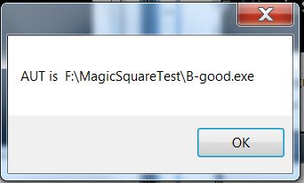

Program A.exe fills the user input for program B-good.exe. This console widow will stay for 5 sec and disappear.

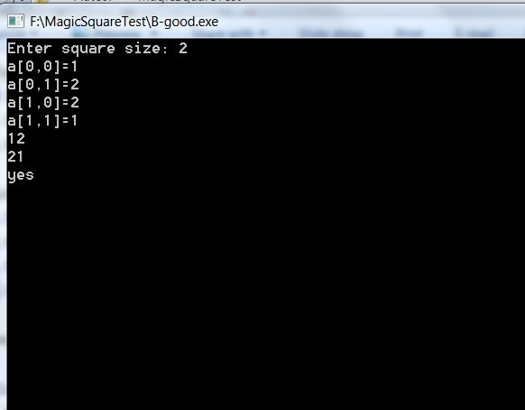

The result of program A.exe testing program B-good.exe:

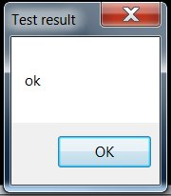

I prepared another program B-bad.exe, which has “yes” and “no” results switched to make the program to give the different expected result.

